3rd Wave Labs 4 Channel AC Controller



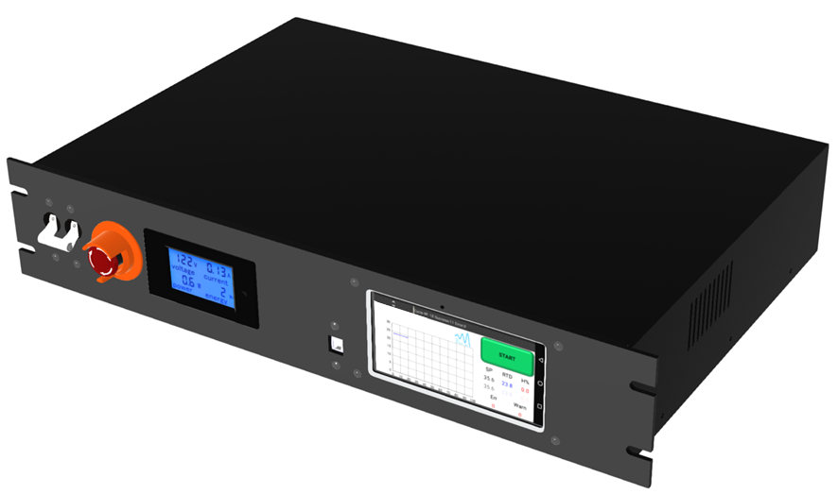

# Power IN Connections

The 4 Channel AC Controller can operate on 120Vac or 240Vac at 30Amps. Please refer to the Tool Placard located on the front of the controller for further information.

It is recommended that the supply circuit be limited to 30Amps to prevent damage to the controller. The ground connection must be connected to earth ground. Failure to connect the ground can pose a safety hazard to the user. Power In terminal screws should be tightened to 0.6-.08Nm.

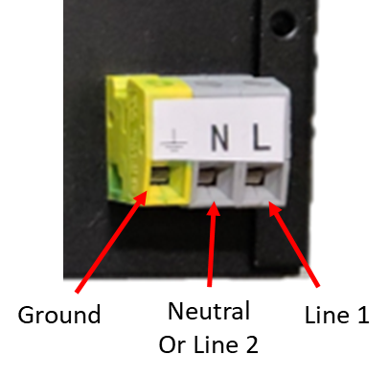

# Emergency Stop

The E-Stop is designed to eliminate the output power to the heaters. When the E-Stop is depressed, the contactor will open & the supply voltage to the solid-state relays will be eliminated. Power to the Primary Control circuitry & displays will still be powered on. An External EMO Switch can be added Via Connections J3-1 & J3-2. If no External EMO is to be used, a jumper must be placed across these two points.

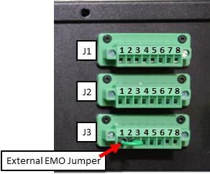

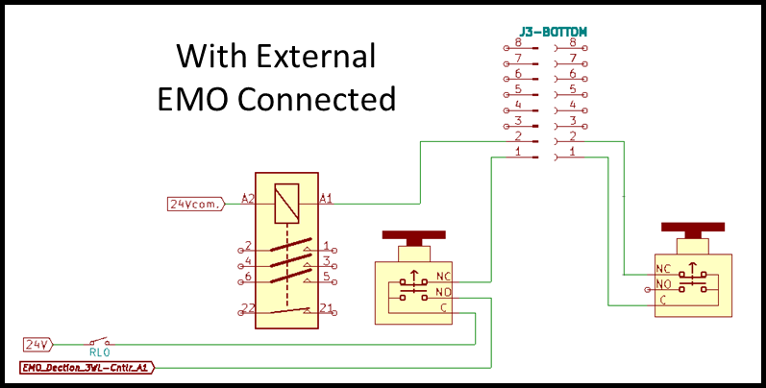

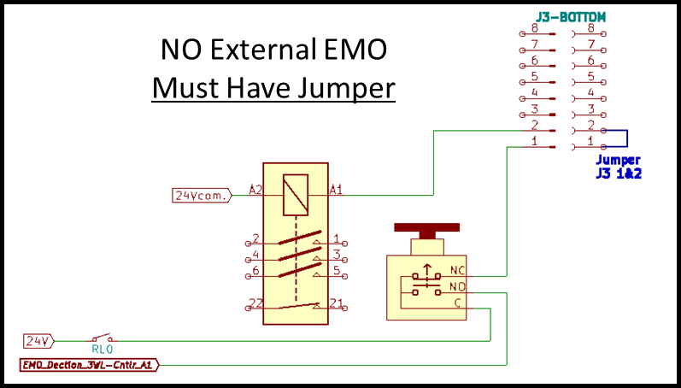

# Heater Connections

**RED & BLUE Connectors have the same connections points.**

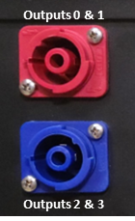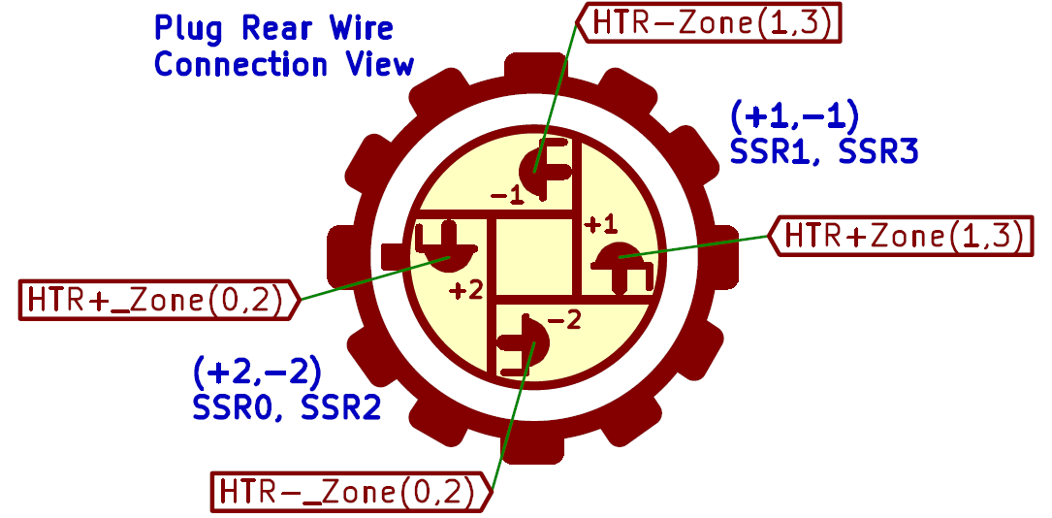

**Available Plug Types & Part Numbers**

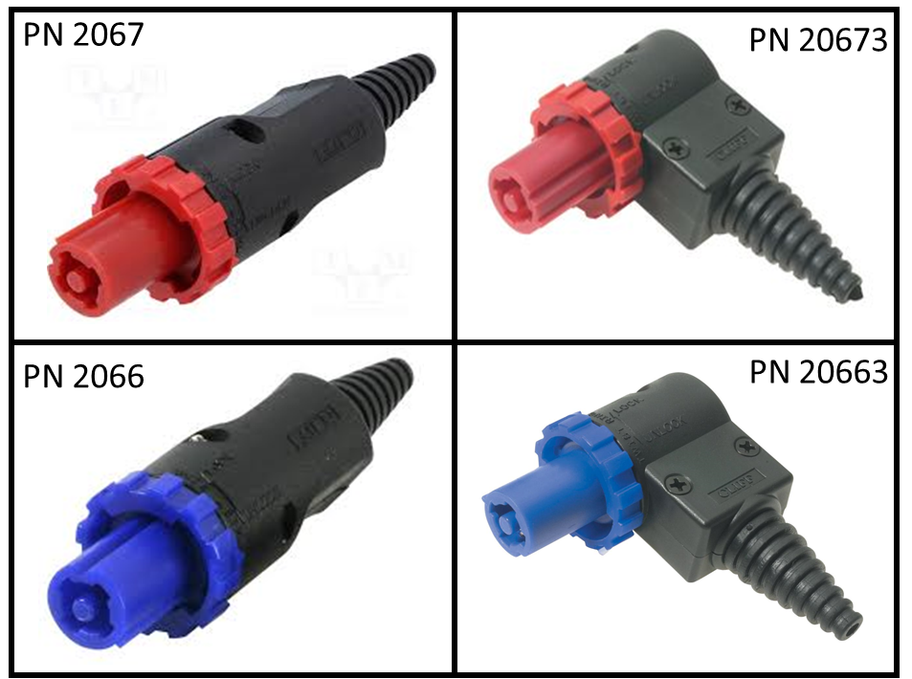

# J1/J2/J3 Connections

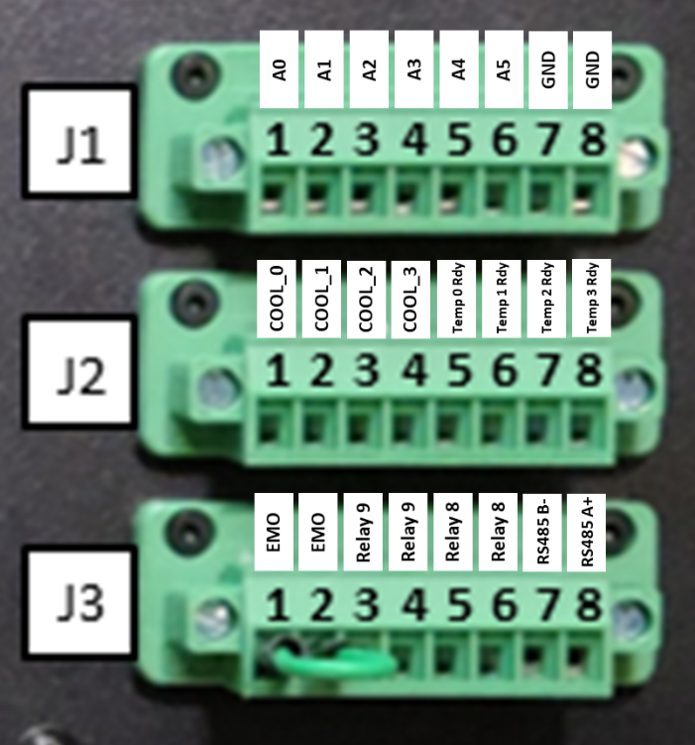

**J1: Analog Inputs(A0-A5)**

* Logic “0” Level: 0V-7.2V
* Logic “1” Level: 18V-26.4V
* Maximum Input Current <3ma

**J2: Digital Outputs(D0-D7)**

* D0-D3 have been configured as the cooling output for each of the respective heater zones(0-3).
* D4-D7 have been configured to provide “Temp Ready” Signals for each of the respective heater zones(0-3).
* Nominal Load Current is 2A (self-limiting)

**J3: EMO/Relays/Communication**

* EMO (pins1 & 2). Provides power to the contactor.
  + Pin1 (24V out)
  + Pin 2 (24V return)
* Relay8 (pins 5&6) & Relay9 (pins 3&4)
  + Resistive Load Max Current: 6A (250Vac/30Vdc)
  + Fuse is recommended
* RS485 Communication (Pin7 B- / Pin8 A+)

# RTD Connections

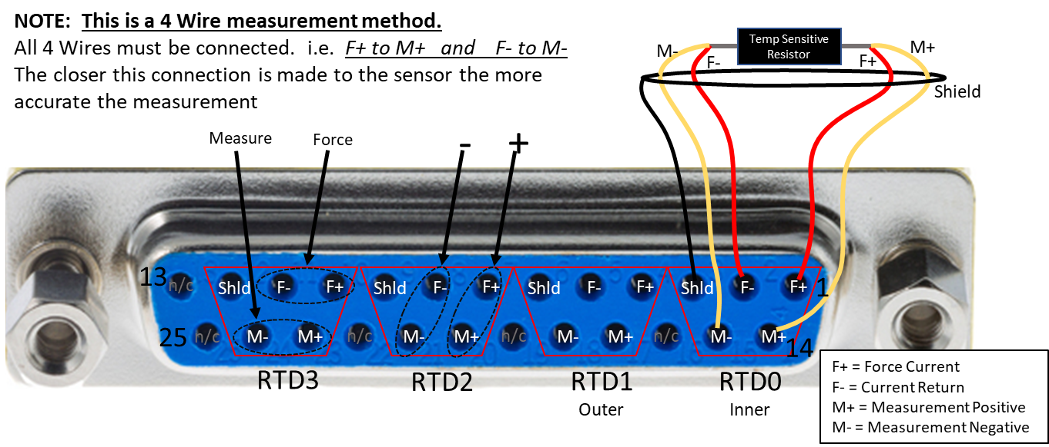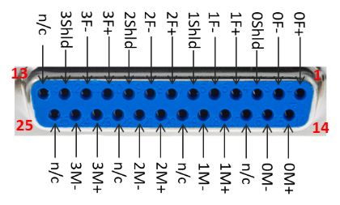

# RTD Reference Resistor Selection

* Rref should be set to 2 to 4x the nominal room temp RTD value. Low end for low temp and high end for high temp to balance resolution and range.
  + 4300 is about 4 times 1000 for an RTD resistance of 1000
* Switches may be of different type. Follow the switch position setting for “ON”
* Enable only one Ref Resistor.
* The corresponding value needs to be set in the HMI application as well.

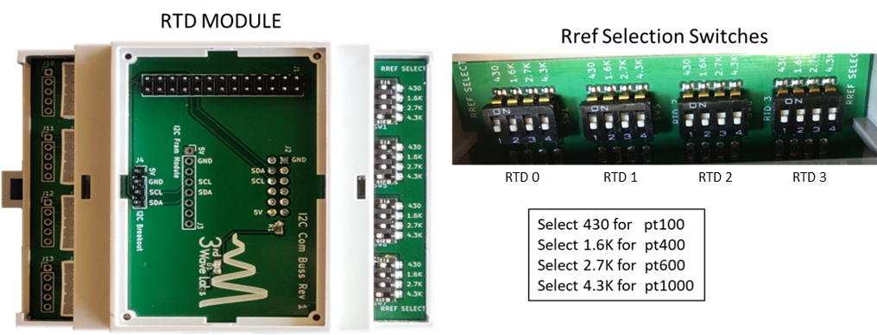

# HMI Control Screens

**OPERATION**

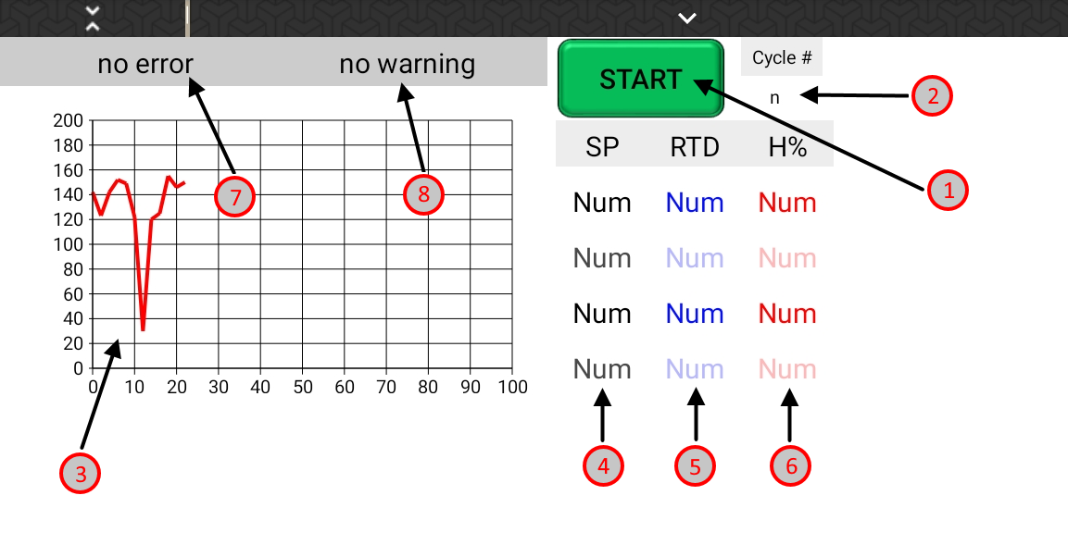

1. Start / Stop Button: when toggled down this sets the controller to heat
2. Cycle Counter: when in profile mode, this indicates the current cycle
3. Temperature Graph: A graph of all 4 Heater zones
4. Setpoints: the current setpoint for each zone in order (0 if disabled)
5. Temperatures: the current temperatures of each zones RTD in order (0 if disabled)
6. Heater %: The drive percent of each zone in order (0 if off or disabled)
7. Error State: The current error state readout from the controller
   1. No Error: the control system is operating normally
   2. Over Temp: temperature has risen over the firmware’s set temp limit
   3. Temp rising while off: The heater temperature is rising while idle
   4. EMO Pressed: The front panel EMO switch has been pressed
8. Warning State: Used as a both a conditional warning output and an area to describe necessary actions to take when an error state is set. For example for error state a-d, the warning state will display “RESET NEEDED”

See Misc Config for reset button.

# HMI Control Screens Cont.

**CONTROL TUNING**

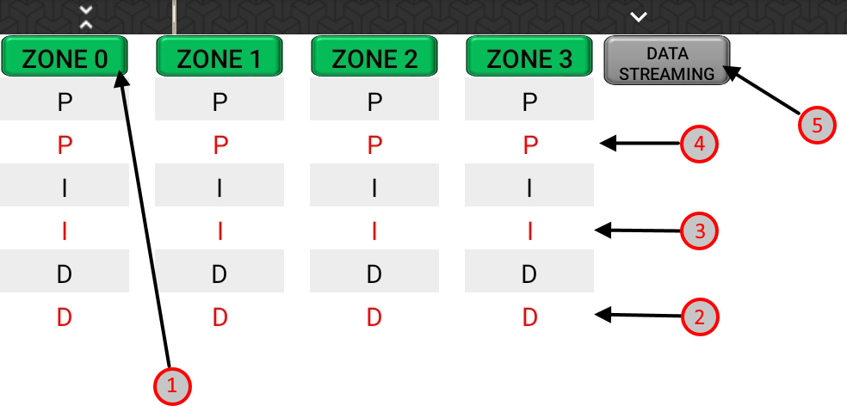

1. Zone Disable: The zone disable button, same functionality for zone 1 – 3
2. Differential Gain: Typically untouched, used to smooth nonlinear sources of oscillation
3. Integral Gain: the weight of cumulative error between setpoint and temp on output
4. Proportional Gain: the weight of current error between setpoint and temp on output.
5. Serial Streaming Enable / Disable: for precise data collection of setpoint, output and temperature. Leave off for normal operation

# HMI Control Screens Cont.

**CALIBRATIONS**

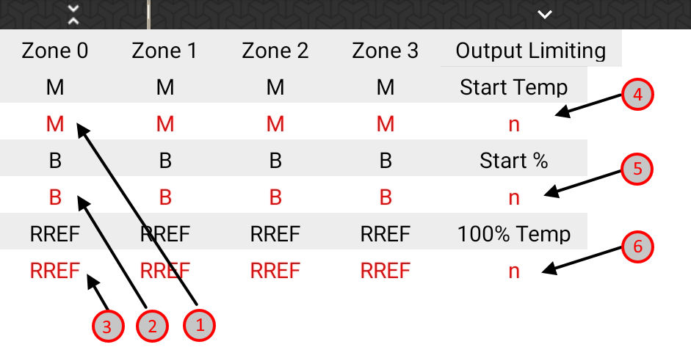

1. M: Resistive heater slope calibration factor for zone n (Temp = M*Resistance - B)
2. B: Resistive heater intercept calibration factor for zone n (Temp = M*Resistance - B)
3. RREF: Reference resistance value for 3rd Wave RTD Module for zone n
4. Start Temp: see graphical description below
5. Start %: see graphical description below
6. 100% Temp: see graphical description below

# HMI Control Screens Cont.

**CALIBRATIONS CONT.**

Graphical Description of 4, 5, and 6:

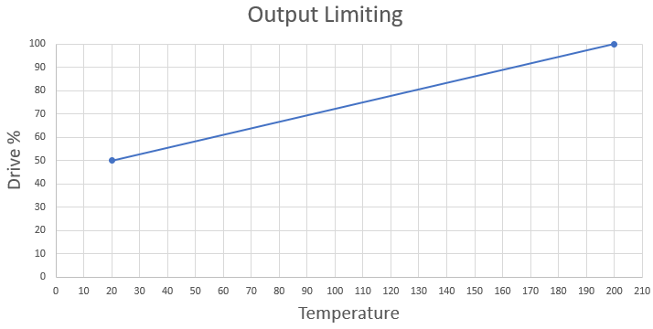

As you can see here, the output is limited to 50% (Start%) at 20 ֯C (Start Temp) and can go to 100% at 210 (100% Temp).

This feature is used in situations where high current through a heater at low temperatures causes damage to the heater.

Normally, default values are set such that the output is 100% at every temperature. For example:

Start Temp = 20

Start % = 100

100% Temp = 100

Warning: if you use this feature, make sure not to set the values in a way that the output limit goes below 0 at any point.

# HMI Control Screens Cont.

**PROFILES**

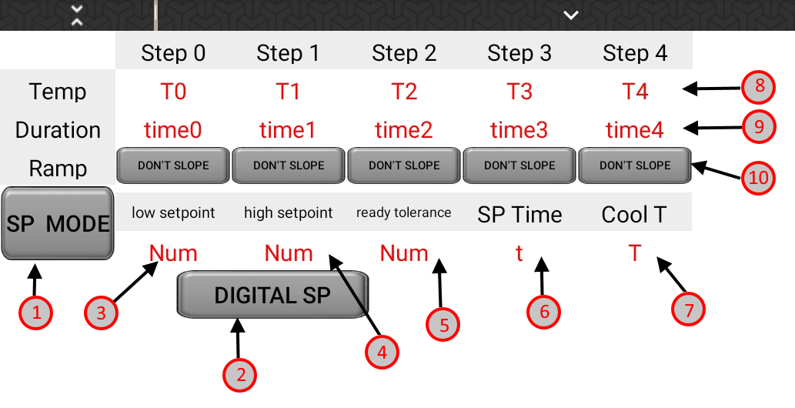

1. Setpoint Mode / Profile Mode Button: Switches control mode between directly controlled setpoint mode, and internal profile mode
2. Digital IO Setpoint / Modbus Setpoint: When in setpoint mode, switches setpoint control between Digital input and Modbus Input.
3. Low Setpoint: When in Digital Setpoint mode, this is the setpoint for a low signal on a digital input thermode zone
4. High Setpoint: When in Digital Setpoint mode, this is the setpoint for a high signal on a digital input for a thermode zone.
5. Ready Tolerance: The temperature region + - the setpoint, that when the temperature is within this region the temp ready digital output will be set high
6. Setpoint Time: The length that setpoint mode will run in seconds. 0 means run until manually stopped
7. Cool Temp: The temperature that cooling will turn off after heating stops
8. Internal Profile Temperatures: See Graphical Description
9. Internal Profile Times: See Graphical Description
10. Slope Control: See Graphical Description

# HMI Control Screens Cont.

Graphical Description of 8, 9, 10:

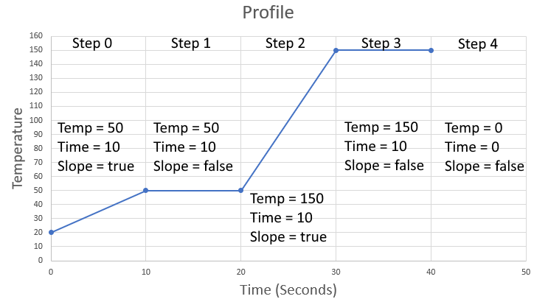

# HMI Control Screens Cont.

**MISC CONFIG**

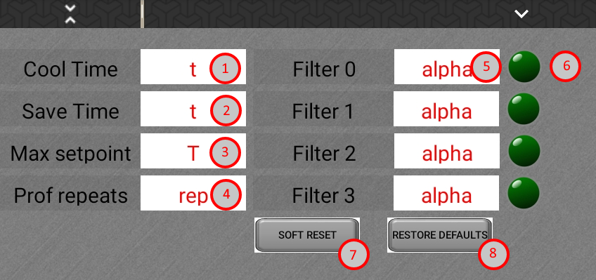

1. Cool Time: Currently unused, Cool Temp is used instead (see profiles page)
2. Save Time: How often Modbus registers are saved to internal memory
3. Max Setpoint: How high the setpoint is allowed to be set
4. Profile Repeats: When in profile mode, how many times a profile will repeat
5. Alpha Filtering: Used to smooth any external noise on RTD reading for each zone. Smaller alpha values mean heavier smoothing with the consequence of a delay in response when a drastic temperature change occurs.
6. Filtering Enable / Disable: When enabled, the alpha smoothing is applied
7. Soft Reset: Triggers a reset in the controller, used to clear error states
8. Restore Defaults: Sets certain registers to default values. Used only for first time setup purposes

# MOD BUS

All Modbus registers:

* have a request type of 16 bit Unsigned Integer
* Use a function code for reading 0x03 Holding Registers
* communicate with PLC ID of 1

For the correctly scaled number in python:

* Scaling factor below: E0 = 1, E1 = 10, E2 = 100,…, EN = 10^N
* Divide by this number after reading i.e. controller.read_register(N) / 10 #for E1
* Multiply by this factor before writing controller.write_register(N, value * 10) #for E1

# MODBUS Registers

|  |  |  |  |  |
| --- | --- | --- | --- | --- |
| **Reg Num** | **Register Name** | **Scaling Factor** | **Type** | **Description** |
| 0 | profile_T0 | E1 | Read/Write, Decimal | Temperature for step 0 in the profile (Degrees C) |
| 1 | profile_T1 | E1 | Read/Write, Decimal | Temperature for step 1 in the profile (Degrees C) |
| 2 | profile_T2 | E1 | Read/Write, Decimal | Temperature for step 2 in the profile (Degrees C) |
| 3 | profile_T3 | E1 | Read/Write, Decimal | Temperature for step 3 in the profile (Degrees C) |
| 4 | profile_T4 | E1 | Read/Write, Decimal | Temperature for step 4 in the profile (Degrees C) |
| 5 | profile_t0 | E1 | Read/Write, Decimal | The duration for step 0 in the profile (Seconds) |
| 6 | profile_t1 | E1 | Read/Write, Decimal | The duration for step 1 in the profile (Seconds) |
| 7 | profile_t2 | E1 | Read/Write, Decimal | The duration for step 2 in the profile (Seconds) |
| 8 | profile_t3 | E1 | Read/Write, Decimal | The duration for step 3 in the profile (Seconds) |
| 9 | profile_t4 | E1 | Read/Write, Decimal | The duration for step 4 in the profile (Seconds) |
| 10 | slope_T0 | E0 | Read/Write, Button(1 or 0) | 0 = Don’t Slope, 1 = Slope (Linearly interpolate between last temp read before start and profile_T0) |
| 11 | slope_T1 | E0 | Read/Write, Button(1 or 0) | 1 = Don’t Slope, 1 = Slope (Linearly interpolate between profile_T0 and profile_T1) |
| 12 | slope_T2 | E0 | Read/Write, Button(1 or 0) | 2 = Don’t Slope, 1 = Slope (Linearly interpolate between profile_T1 and profile_T2) |
| 13 | slope_T3 | E0 | Read/Write, Button(1 or 0) | 2 = Don’t Slope, 1 = Slope (Linearly interpolate between profile_T2 and profile_T3) |
| 14 | slope_T4 | E0 | Read/Write, Button(1 or 0) | 3 = Don’t Slope, 1 = Slope (Linearly interpolate between profile_T3 and profile_T4) |
| 15 | p0 | E2 | Read/Write, Decimal | Proportional gain for zone 0 |
| 16 | i0 | E2 | Read/Write, Decimal | Integral gain for zone 0 |
| 17 | d0 | E2 | Read/Write, Decimal | Differential gain for zone 0 |
| 18 | m0 | E3 | Read/Write, Decimal | Resistive heater slope calibration factor for zone 0 (Temp = M*Resistance - B) |
| 19 | b0 | E1 | Read/Write, Decimal | Resistive heater intercept calibration factor for zone 0 (Temp = M*Resistance - B) |
| 20 | rref0 | E0 | Read/Write, Integer | Reference resistance value for 3rd Wave RTD Module for zone 0 |
| 21 | p1 | E2 | Read/Write, Decimal | Proportional gain for zone 1 |
| 22 | i1 | E2 | Read/Write, Decimal | Integral gain for zone 1 |
| 23 | d1 | E2 | Read/Write, Decimal | Differential gain for zone 1 |
| 24 | m1 | E3 | Read/Write, Decimal | Resistive heater slope calibration factor for zone 1 (Temp = M*Resistance - B) |
| 25 | b1 | E1 | Read/Write, Decimal | Resistive heater intercept calibration factor for zone 1 (Temp = M*Resistance - B) |
| 26 | rref1 | E0 | Read/Write, Integer | Reference resistance value for 3rd Wave RTD Module for zone 1 |
| 27 | p2 | E2 | Read/Write, Decimal | Proportional gain for zone 2 |
| 28 | i2 | E2 | Read/Write, Decimal | Integral gain for zone 2 |
| 29 | d2 | E2 | Read/Write, Decimal | Differential gain for zone 2 |
| 30 | m2 | E3 | Read/Write, Decimal | Resistive heater slope calibration factor for zone 2 (Temp = M*Resistance - B) |
| 31 | b2 | E1 | Read/Write, Decimal | Resistive heater intercept calibration factor for zone 2 (Temp = M*Resistance - B) |
| 32 | rref2 | E0 | Read/Write, Integer | Reference resistance value for 3rd Wave RTD Module for zone 2 |
| 33 | p3 | E2 | Read/Write, Decimal | Proportional gain for zone 3 |
| 34 | i3 | E2 | Read/Write, Decimal | Integral gain for zone 3 |
| 35 | d3 | E2 | Read/Write, Decimal | Differential gain for zone 3 |
| 36 | m3 | E3 | Read/Write, Decimal | Resistive heater slope calibration factor for zone 3 (Temp = M*Resistance - B) |
| 37 | b3 | E1 | Read/Write, Decimal | Resistive heater intercept calibration factor for zone 3 (Temp = M*Resistance - B) |
| 38 | rref3 | E0 | Read/Write, Integer | Reference resistance value for 3rd Wave RTD Module for zone 3 |
| 39 | p4 | E2 | Read/Write, Decimal | Proportional gain for zone 4 |
| 40 | i4 | E2 | Read/Write, Decimal | Integral gain for zone 4 |
| 41 | d4 | E2 | Read/Write, Decimal | Differential gain for zone 4 |
| 42 | m4 | E3 | Read/Write, Decimal | Resistive heater slope calibration factor for zone 4 (Temp = M*Resistance - B) |
| 43 | b4 | E1 | Read/Write, Decimal | Resistive heater intercept calibration factor for zone 4 (Temp = M*Resistance - B) |
| 44 | rref4 | E0 | Read/Write, Integer | Reference resistance value for 3rd Wave RTD Module for zone 4 |
| 45 | p5 | E2 | Read/Write, Decimal | Proportional gain for zone 5 |
| 46 | i5 | E2 | Read/Write, Decimal | Integral gain for zone 5 |
| 47 | d5 | E2 | Read/Write, Decimal | Differential gain for zone 5 |
| 48 | m5 | E3 | Read/Write, Decimal | Resistive heater slope calibration factor for zone 5 (Temp = M*Resistance - B) |
| 49 | b5 | E1 | Read/Write, Decimal | Resistive heater intercept calibration factor for zone 5 (Temp = M*Resistance - B) |
| 50 | rref5 | E0 | Read/Write, Integer | Reference resistance value for 3rd Wave RTD Module for zone 5 |
| 51 | p6 | E2 | Read/Write, Decimal | Proportional gain for zone 6 |
| 52 | i6 | E2 | Read/Write, Decimal | Integral gain for zone 6 |
| 53 | d6 | E2 | Read/Write, Decimal | Differential gain for zone 6 |
| 54 | m6 | E3 | Read/Write, Decimal | Resistive heater slope calibration factor for zone 6 (Temp = M*Resistance - B) |
| 55 | b6 | E1 | Read/Write, Decimal | Resistive heater intercept calibration factor for zone 6 (Temp = M*Resistance - B) |
| 56 | rref6 | E0 | Read/Write, Integer | Reference resistance value for 3rd Wave RTD Module for zone 6 |
| 57 | p7 | E2 | Read/Write, Decimal | Proportional gain for zone 7 |
| 58 | i7 | E2 | Read/Write, Decimal | Integral gain for zone 7 |
| 59 | d7 | E2 | Read/Write, Decimal | Differential gain for zone 7 |
| 60 | m7 | E3 | Read/Write, Decimal | Resistive heater slope calibration factor for zone 7 (Temp = M*Resistance - B) |
| 61 | b7 | E1 | Read/Write, Decimal | Resistive heater intercept calibration factor for zone 7 (Temp = M*Resistance - B) |
| 62 | rref7 | E0 | Read/Write, Integer | Reference resistance value for 3rd Wave RTD Module for zone 7 |
| 63 | setpoint0 | E1 | Read/Write, Decimal | The desired temperature to reach when heating ("heat" register 75 is 1) for zone 0 |
| 64 | setpoint1 | E1 | Read/Write, Decimal | The desired temperature to reach when heating ("heat" register 75 is 1) for zone 1 |
| 65 | setpoint2 | E1 | Read/Write, Decimal | The desired temperature to reach when heating ("heat" register 75 is 1) for zone 2 |
| 66 | setpoint3 | E1 | Read/Write, Decimal | The desired temperature to reach when heating ("heat" register 75 is 1) for zone 3 |
| 67 | setpoint4 | E1 | Read/Write, Decimal | The desired temperature to reach when heating ("heat" register 75 is 1) for zone 4 |
| 68 | setpoint5 | E1 | Read/Write, Decimal | The desired temperature to reach when heating ("heat" register 75 is 1) for zone 5 |
| 69 | setpoint6 | E1 | Read/Write, Decimal | The desired temperature to reach when heating ("heat" register 75 is 1) for zone 6 |
| 70 | setpoint7 | E1 | Read/Write, Decimal | The desired temperature to reach when heating ("heat" register 75 is 1) for zone 7 |
| 71 | setpoint_heat_time | E1 | Read/Write, Decimal | Time in seconds that setpoint mode lasts before it shuts itself off (0 for no limit) |
| 72 | [Unused] | - | - | - |
| 73 | save_time | E1 | Read/Write, Decimal | How often Modbus register values are saved to controller memory module (seconds) |
| 74 | max_setpoint | E1 | Read/Write, Decimal | Setpoint data entry limit. Any setpoint entered above this value will be reset to this value |
| 75 | heat | E0 | Read/Write, Button(1 or 0) | 0 = idle, 1 = start heating |
| 76 | mode | E0 | Read/Write, Button(1 or 0) | 0 = setpoint mode (individual setpoints or externally defined profile), 1 = internal profile mode |
| 77 | input0 | E1 | Read Only, Decimal | The current read temperature of zone 0 |
| 78 | input1 | E1 | Read Only, Decimal | The current read temperature of zone 1 |
| 79 | input2 | E1 | Read Only, Decimal | The current read temperature of zone 2 |
| 80 | input3 | E1 | Read Only, Decimal | The current read temperature of zone 3 |
| 81 | input4 | E1 | Read Only, Decimal | The current read temperature of zone 4 |
| 82 | input5 | E1 | Read Only, Decimal | The current read temperature of zone 5 |
| 83 | input6 | E1 | Read Only, Decimal | The current read temperature of zone 6 |
| 84 | input7 | E1 | Read Only, Decimal | The current read temperature of zone 7 |
| 85 | output0 | E1 | Read Only, Decimal | The drive percent being written to the SSR's for zone 0 |
| 86 | output1 | E1 | Read Only, Decimal | The drive percent being written to the SSR's for zone 1 |
| 87 | output2 | E1 | Read Only, Decimal | The drive percent being written to the SSR's for zone 2 |
| 88 | output3 | E1 | Read Only, Decimal | The drive percent being written to the SSR's for zone 3 |
| 89 | output4 | E1 | Read Only, Decimal | The drive percent being written to the SSR's for zone 4 |
| 90 | output5 | E1 | Read Only, Decimal | The drive percent being written to the SSR's for zone 5 |
| 91 | output6 | E1 | Read Only, Decimal | The drive percent being written to the SSR's for zone 6 |
| 92 | output7 | E1 | Read Only, Decimal | The drive percent being written to the SSR's for zone 7 |
| 93 | [Unused] | - | - | - |
| 94 | error_codes | E0 | Read Only, Integer | Code corresponding to a specific error, See error table |
| 95 | warning_codes | E0 | Read Only, Integer | Warning corresponding to action taken on a specific error code |
| 96 | start_percent | E0 | Read/Write, Integer | The percent that output is limited to at room_temp. Integer of percent values 0 -> 100 |
| 97 | room_temp | E1 | Read/Write, Decimal | The temperature (C) at which output is limited by start_percent |
| 98 | max_temp | E1 | Read/Write, Decimal | The temperature (C) at which output is not limited (100 %) |
| 99 | serial_streaming | E0 | Read/Write, Button(1 or 0) | 0 = Serial data stream on USB disabled, 1 = Serial data stream on USB enabled. |
| 100 | [Unused] | - | - | - |
| 101 | [Unused] | - | - | - |
| 102 | disable0 | E0 | Read/Write, Button(1 or 0) | 0 = Zone 0 enabled, 1 = Zone 0 disabled |
| 103 | disable1 | E0 | Read/Write, Button(1 or 0) | 0 = Zone 1 enabled, 1 = Zone 1 disabled |
| 104 | disable2 | E0 | Read/Write, Button(1 or 0) | 1 = Zone 2 enabled, 1 = Zone 2 disabled |
| 105 | disable3 | E0 | Read/Write, Button(1 or 0) | 1 = Zone 3 enabled, 1 = Zone 3 disabled |
| 106 | disable4 | E0 | Read/Write, Button(1 or 0) | 2 = Zone 4 enabled, 1 = Zone 4 disabled |
| 107 | disable5 | E0 | Read/Write, Button(1 or 0) | 2 = Zone 5 enabled, 1 = Zone 5 disabled |
| 108 | disable6 | E0 | Read/Write, Button(1 or 0) | 3 = Zone 6 enabled, 1 = Zone 6 disabled |
| 109 | disable7 | E0 | Read/Write, Button(1 or 0) | 3 = Zone 7 enabled, 1 = Zone 7 disabled |
| 110 | cool_temp | E1 | Read/Write, Decimal | The temperature threshold for cooling, cooling will stop after temp is below this value |
| 111 | filtering0 | E0 | Read/Write, Button(1 or 0) | 0 = Disable filtering, 1 = Enable filtering for zone 0 |
| 112 | filtering1 | E0 | Read/Write, Button(1 or 0) | 0 = Disable filtering, 1 = Enable filtering for zone 1 |
| 113 | filtering2 | E0 | Read/Write, Button(1 or 0) | 0 = Disable filtering, 1 = Enable filtering for zone 2 |
| 114 | filtering3 | E0 | Read/Write, Button(1 or 0) | 0 = Disable filtering, 1 = Enable filtering for zone 3 |
| 115 | filtering4 | E0 | Read/Write, Button(1 or 0) | 0 = Disable filtering, 1 = Enable filtering for zone 4 |
| 116 | filtering5 | E0 | Read/Write, Button(1 or 0) | 0 = Disable filtering, 1 = Enable filtering for zone 5 |
| 117 | filtering6 | E0 | Read/Write, Button(1 or 0) | 0 = Disable filtering, 1 = Enable filtering for zone 6 |
| 118 | filtering7 | E0 | Read/Write, Button(1 or 0) | 0 = Disable filtering, 1 = Enable filtering for zone 7 |
| 119 | alpha0 | E3 | Read/Write, Decimal | Weighted smoothing factor for zone 0 (Alpha is the complementary percent applied to each new data sample) |
| 120 | alpha1 | E3 | Read/Write, Decimal | Weighted smoothing factor for zone 1 |
| 121 | alpha2 | E3 | Read/Write, Decimal | Weighted smoothing factor for zone 2 |
| 122 | alpha3 | E3 | Read/Write, Decimal | Weighted smoothing factor for zone 3 |
| 123 | alpha4 | E3 | Read/Write, Decimal | Weighted smoothing factor for zone 4 |
| 124 | alpha5 | E3 | Read/Write, Decimal | Weighted smoothing factor for zone 5 |
| 125 | alpha6 | E3 | Read/Write, Decimal | Weighted smoothing factor for zone 6 |
| 126 | alpha7 | E3 | Read/Write, Decimal | Weighted smoothing factor for zone 7 |
| 127 | link_filter | E0 | Read/Write, Button(1 or 0) | All filtering registers will follow the filter enable and alpha register 0 (alpha0 also writes to alpha1-alpha7, filtering0 to filtering0-filtering7) |
| 128 | [Unused] | - | - | - |
| 129 | num_profile_repeats | E0 | Read/Write, Integer | When in profile mode, the profile will repeat after cooling this many times, 0 is no repeat, 1 is one repeat… |
| 130 | profileRepeatCount | E0 | Read Only, Integer | The current cycle count when profile repeat is > 0 |
| 131 | soft_reset | E0 | Read/Write, Button(1 or 0) | Setting this to 1 restarts the controller, automatically sets self back to 0 after write |
| 132 | restore_defaults | E0 | Read/Write, Button(1 or 0) | Setting this to 1 sets certain important registers to default values, automatically sets self back to 0 after write. Used only for first time setup by 3rd Wave labs |
| 133 | modbus_control | E0 | Read/Write, Button(1 or 0) | 0 = Digital I/0 control of setpoint, 1 = Modbus control of setpoint |
| 134 | high_setpoint | E1 | Read/Write, Decimal | When mobus_control is 0, setpointN will be set to this temperature when Digital input Thermode_Temp_N is high (1) |
| 135 | low_setpoint | E1 | Read/Write, Decimal | When mobus_control is 0, setpointN will be set to this temperature when Digital input Thermode_Temp_N is low (0) |
| 136 | temp_ready_tolerance | E1 | Read/Write, Decimal | When inputN is within this value + or - setpointN, digital output Temp_N_Ready will be set high |

# Initial Power on Sequence

Front Panel

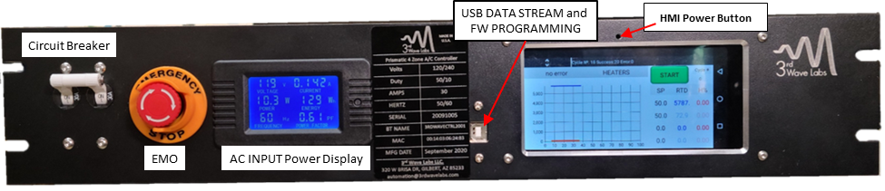

1. Ensure that mains external power is connected and on
2. Emergency stop button (EMO) should be depressed
3. Toggle the front panel circuit breaker to the on position (
4. Use 2.5mm key (or similar small diameter screw driver) inserted and then apply a downward press and wait ~15 seconds. The power splash screen will appear and the boot sound.

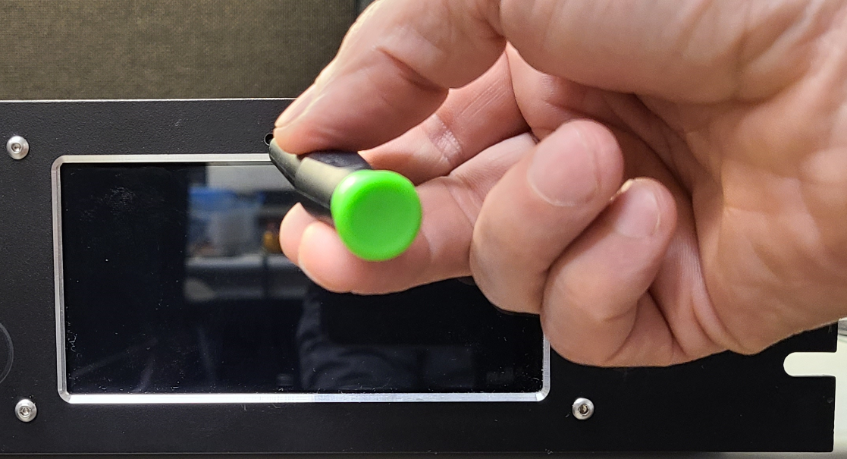

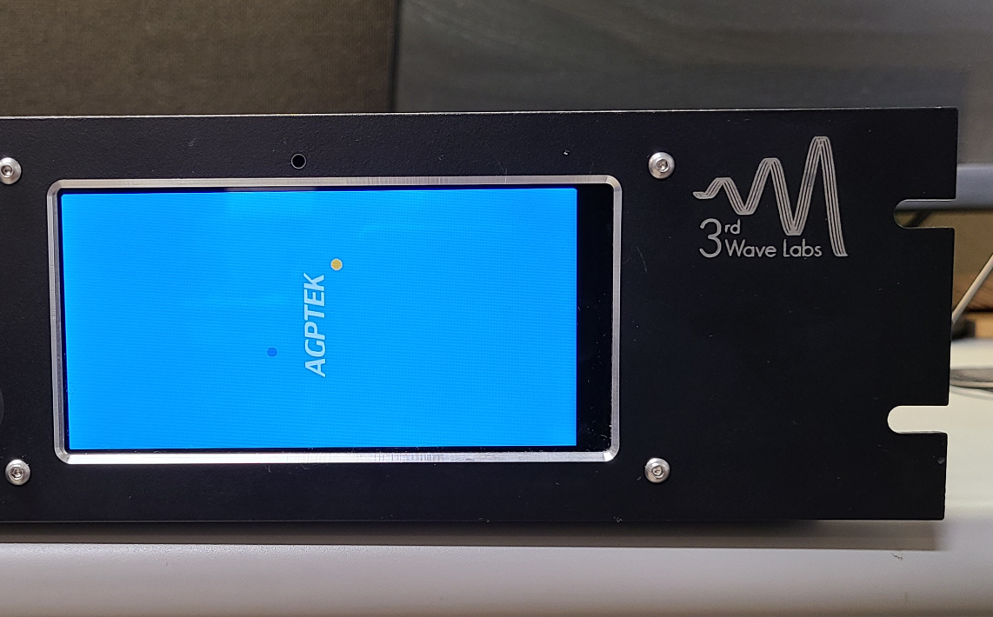

1. Apply a right to left swipe to the touchscreen for login (upward with respect to screen rotation).
2. Note screen may take an additional 15 seconds to sense orientation and rotate to the horizontal view
3. Tap the Green HMI modbus viewer icon to start the HMI loader and select “load last project”.

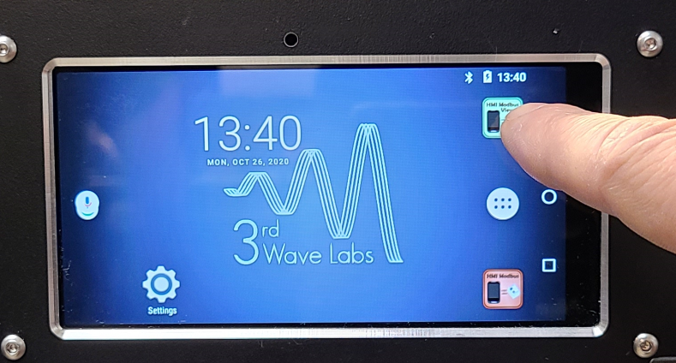

Rear Panel Exterior

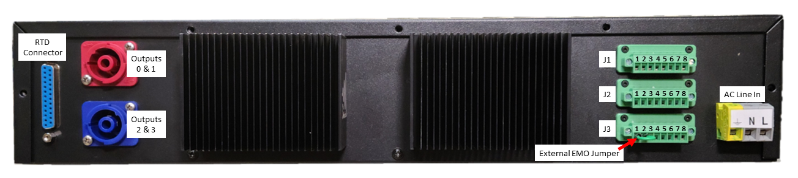

# Connector Pin List

